Lab 2 PHY-Layer Simulation Using GNURadio

Part 1 - Introduction
In this lab, you will use GNU Radio to implement two digital modulation schemes: Binary Phase Shift Keying (BPSK) and Quaternary Phase Shift Keying (QPSK).
By completing this lab, you will learn:
- How BPSK and QPSK work, and how to apply the Maximum Likelihood (ML) method for decoding.
- How the Bit Error Rate (BER) changes as the Signal-to-Noise Ratio (SNR) increases.
- (Grad student) Why Gray coding helps reduce BER compared to standard binary mapping.
GNU Radio:
GNU Radio is a free and open-source software development toolkit used to implement software-defined radios (SDRs). A software-defined radio is a radio communication system in which most signal processing tasks are performed in software, rather than using dedicated hardware circuits. This approach reduces the need for specialized radio hardware; typically, the only hardware required is:
- A high-speed ADC (Analog-to-Digital Converter) to sample signals received from the antenna.
- A DAC (Digital-to-Analog Converter) to convert digital signals back into electromagnetic waves for transmission.
GNU Radio includes a graphical interface called the GNU Radio Companion (GRC), which enables users to design signal-processing applications through a drag-and-drop interface [1].
- Each design file in GRC is called a flowgraph, which defines the path of data from a source (e.g., signal generator or file) to a sink (e.g., spectrum display or audio output).
- Each operation in the flowgraph is represented as a block, with specific blocks handling tasks such as modulation, filtering, or noise addition.

Starting up GRC:
If you are using the Ubuntu VirtualBox instance, for this lab, we have an updated image with upgraded software: Ubuntu 22.04 with GNU Radio 3.10.1. Please substitute your previous image with the upgrade which you can download from this link : Virtualbox_update
If you are not using the provided virtual box, please refer to the Configuration Guide for the Linux Environment (ECSE 4660/6660) and follow the steps there to set up your environment. However, install/upgrade Ubuntu to v22.04 and GNU Radio to v3.10.1, as the lab instructions have been tested on these versions. GNU 3.10.1 will be installed automatically on Ubuntu 22.04 if you run “sudo apt-get install gnuradio”.
You can see https://wiki.gnuradio.org/index.php?title=InstallingGR for reference.

Install Out-Of-Tree module:
We provide a ground-truth Out-of-Tree (OOT) module specifically designed for this lab. This module will help you verify the correctness of your implementation and speed up data collection. At the same time, installing it will give you hands-on experience with the typical compile-and-install process in Linux.
- Navigate to your working directory. For example, if you are using the provided Ubuntu instance, run:
cd /home/iot/Gnuradio/Gnuradioworkspace
- Follow the installation instructions in the “How to use?” section of the repository:
👉 https://github.com/ChibuikemEzemaduka/gr-rpi_iot/tree/master
This will guide you through downloading, compiling, and installing the OOT module so it can be used within GNU Radio Companion.

Download the following two GNU Radio Companion (GRC) flowgraph files for this lab:
- BPSK_BER_simulation.grc
BPSK grc
- QPSK_BER_simulation.grc
QPSK grc
Save both files to your working directory (e.g., /home/iot/Gnuradio/Gnuradioworkspace).
Execute the following command in the terminal to start the Gnuradio GUI environment:
gnuradio-companion &
An untitled GRC window should appear. Click ‘Open’ to access the ‘BPSK_BER_simulation.grc’ or ‘QPSK_BER_simulation.grc’ flowgraph to be used in this lab.

Part 2 - The BPSK and QPSK Modulation Schemes
BPSK and QPSK are two fundamental digital modulation schemes:
- BPSK maps one input bit to one output symbol.
- QPSK maps two input bits to one output symbol.
The mapping relationships are shown in the table below:

Modulation | Data Bit(s) | Symbol
BPSK | 0 | -1
BPSK | 1 | 1
QPSK | 00 | -1-j
QPSK | 01 | 1-j
QPSK | 10 | -1+j
QPSK | 11 | 1+j

For both ECSE 4660 and ECSE 6660 students, your tasks are to:
- Come up with a decoding method to decode BPSK and QPSK code;
- Implement your decoding method with Python3 in block
  - “BPSK Decoder” and “BER for BPSK” in ‘BPSK_BER_simulation.grc”;
  - “QPSK Decoder” and “BER for QPSK” in “QPSK_BER_simulation.grc”;
- Run the flowgraph and filling in the table in Appendix A and Appendix B. You are allowed to use our provided BER block to do the simulation.
- Plot the BER-vs-SNR plot with log-scale y-axis (e.g. using the semiology function in python.matplotlib or Matlab, or plot log(BER)-vs-SNR if you don’t know how to do that.)
For ECSE 6660 students, your additional task tasks are:
- Modify the parameter in “QPSK_MAP” to implement the following new constellation modulation
Modulation | Data Bit(s) | Symbol
QPSK | 00 | -1-j
QPSK | 01 | 1-j
QPSK | 10 | 1+j
QPSK | 11 | -1+j
then redo task 3 and 4.
- Comparing to the original constellation modulation, which one has lower BER under the same SNR? Explain briefly why this would happen?

Hints and Explanations:
- The input to the BPSK/QPSK Decoder block is of data type numpy.array(numpy.complex). You may need to deal with the real and imaginary part of each number
- For BPSK, BER is equivalent to Symbol-Error-Rate. You can simply check how many decoded symbols are different from the ground truth symbols. For QPSK, you have to do a bit-wise comparison. For example, 2 and 3 are different in symbols, but their corresponding binary bits differ in only one bit. Similarly, 1 and 4 differ in two bits.
- To make the BER measurement more precise, we adopt the idea of sliding window. We create a member variable named self.window in the block with length 1,000,000. The self.window always stores the most recent 1,000,000 comparison results. Therefore, BER is computed out from relatively large amount of data.
For example, if the block stores 200 results in self.window[0:199], when the block needs to store another 300 results, the corresponding location is self.window[200: 499].
- The chunks_to_symbols block works by treating the input variable as a lookup table. Since the data source randomly generates numbers in range 0~1 or 0~3, the output of the chunks_to_symbols block maps 0~1 to BPSK_MAP[0] and BPSK_MAP [1] and 0~3 to QPSK_MAP[0] … QPSK_MAP[3].

More explanations of the flowgraph:
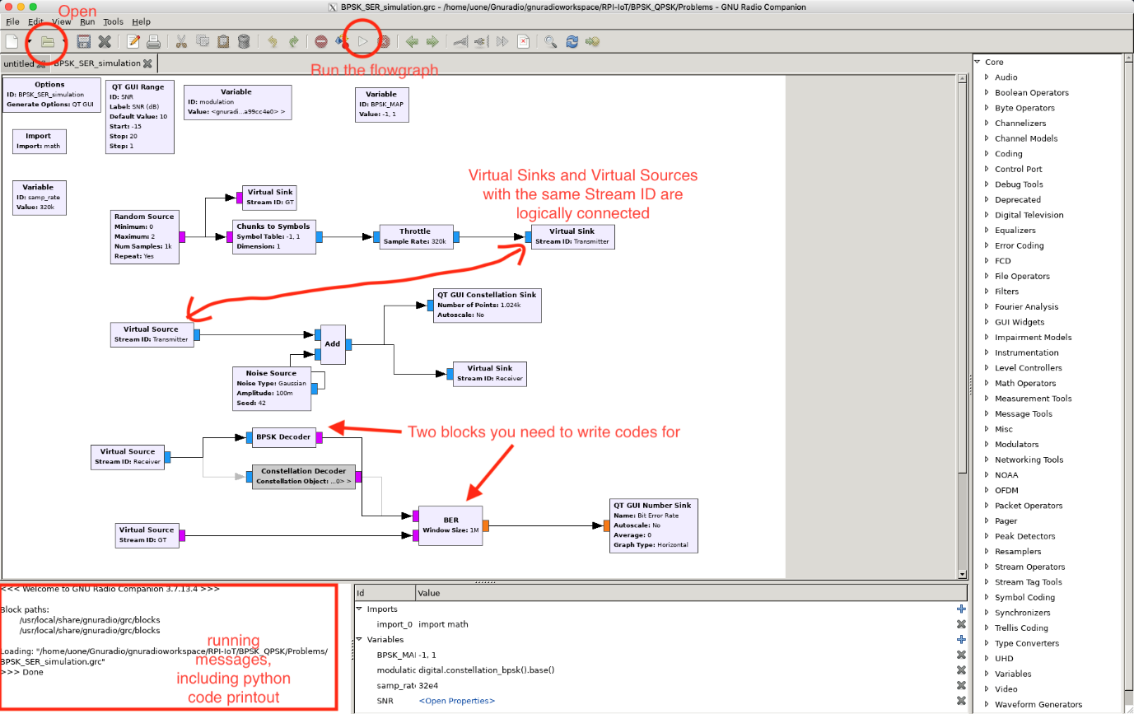
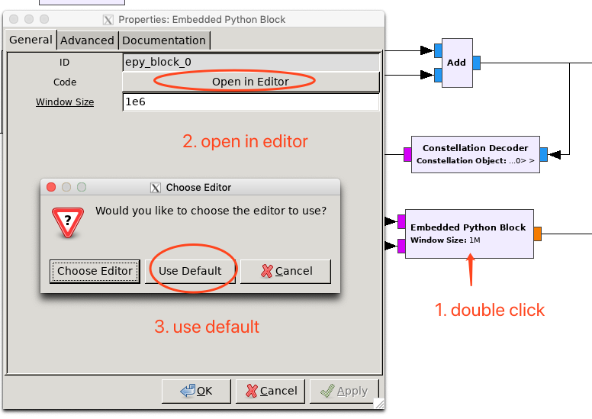
The flow graph uses a ‘Random Source’ block to generate the original signal. The ‘Chunks to Symbols’ block maps the incoming data to a symbol according to the following mapping table:

The ‘Noise Source’ introduces the Gaussian noise of a predetermined amplitude to the original signal. This source models the process of a signal becoming noisy as it is transmitted through a channel.
The ‘BPSK Decoder’ or ‘QPSK Decoder’ decodes the incoming BPSK-modulated signal to bytes. This stage represents the receiver. The block named “BER” is used to compute the Bit-Error-Rate. It takes in two inputs: the original signal and the decoded signal. Its purpose is to determine the number of bit-errors introduced by the noisy channel within a fixed window size.

Run the flowgraph by clicking on the ‘Run’ button on the toolbar. This will open a new window displaying the signal constellation of the noisy signal and the BER. You should also be able to increase or decrease the SNR value by moving the bar to the left or to the right.
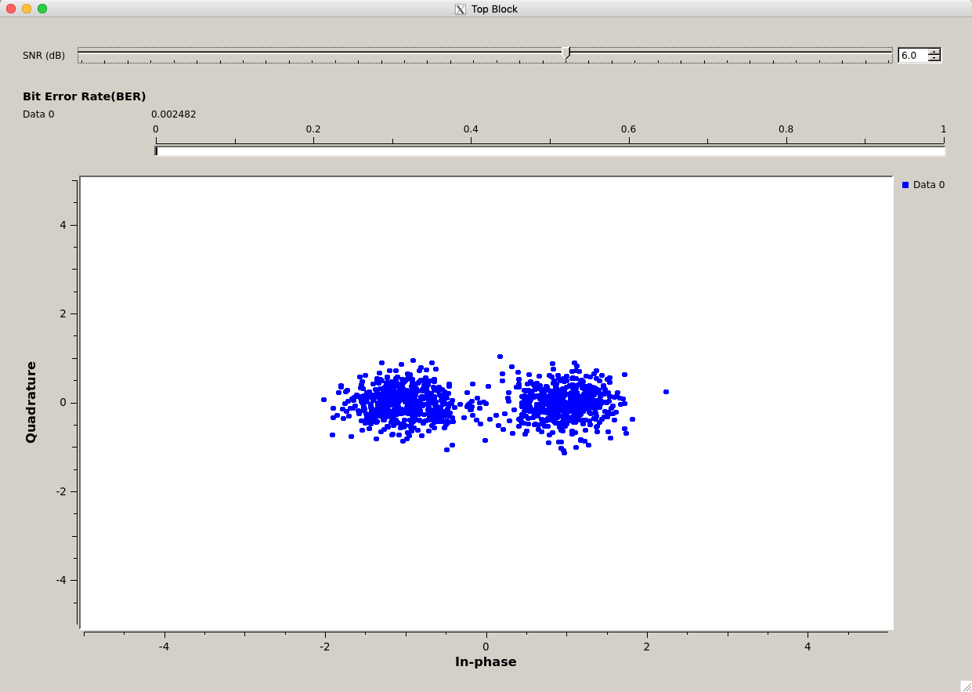

Deliverables:
Include the followings in your report and submit to LMS
- (Both ECSE 4660 and ECSE 6660 students Describe and explain concisely the effect on the BPSK or QPSK signal constellations when the SNR value is increased or decreased. Scratch the constellation of QPSK in complex coordinate plane.
- (both ECSE 4660 and ECSE 6660 students) Concisely describe your decoding methods. Also, include your code as an Appendix in your report.
- (ECSE 6660 students) Scratch the new constellation of QPSK as well. Answer the question in Part 2 task 6.
- (both ECSE 4660 and ECSE 6660 students) Record the BER readings using tables in the Appendix (correct to 3 significant figures) for the SNR values given in the table. Describe and explain the observed trend in a few sentences.
- (both ECSE 4660 and ECSE 6660 students) Generate plots from the readings you collect. Use the ‘semilogy’ command if you are using MATLAB, python.matplotlib.semilogy, or manually taking a logarithm to the BER to plot the log(BER)-vs-SNR.
- (both ECSE 4660 and ECSE 6660 students) Determine the SNR values beyond which the symbols can be decoded with great accuracy (BER < 0.0001) for BPSK and QPSK modulations. You can manually type a more precise SNR in the GUI while running the flowgraph. Reading from your plotted graph is also a reasonable method.
- (ECSE 6660 students) Should BER vs SNR curve for BPSK and QPSK the same? Why or why not?

If you have any questions, please ask on Piazza, or email the Lab TA:

· Chibuikem Ezemaduka (ezemac@rpi.edu)

Appendix A
SNR (dB) | BER for BPSK
-15
-12
-9
-6
-3
-2
-1
0
1
2
3
4
5
6

Appendix B
SNR (dB) | BER for QPSK
-15
-12
-9
-6
-3
-2
-1
0
1
2
3
4
5
6

The documentation for GNU Radio may be found in [2].

[1] https://wiki.gnuradio.org/index.php/What_is_GNU_Radio%3F
[2] https://www.gnuradio.org/doc/doxygen/

